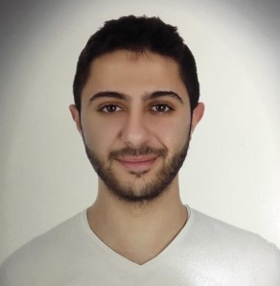
Souhad Khalil Saleh
Contact Number: | +961 78964743
Email Address: | souhad.k.saleh@hotmail.com
OBJECTIVE
Looking forward to associate myself with an organization where I will have the opportunity to improve my knowledge for self-development and self-experience as I will take advantage to use my skills in the best possible way for achieving the company’s goals.
EXPERIENCE
- PricewaterhouseCoopers, Riyadh
Internship - Deals, Transaction Services July - Sept. (2016)

EDUCATION
- University of Saint-Joseph, Saida
Business Administration & Management 2014 – present
- Middle East International School, Riyadh
French Baccalaureate (Science) 2013
EXTRA-CURRICULAR ACTIVITIES
- Certificate From THAT Institution, Beirut
NLP (Neuro Linguistic Programming) 2017
Used for personal development and for success in business.
- Training Certificate From AUB & USJ, Beirut
Empowering Leadership & Communication Skills 2017
Advocacy & Lobbying 2017
Used to accomplish the required organization goals.
- Training Certificate From Lebanese Red Cross, Saida
First Aid Training 2017
- Member of the Social Student Life, University of Saint-Joseph 2015-2017
SKILLS
- Fluent in written and verbal communication in Arabic (Native), English, French.
- Written and verbal communication in Chinese (Level 1)
- MS Office (Word, Excel, PowerPoint, Access)
- Team work spirit.
- Quick learner.
- Organized-schedule planning.
- Enhanced performance and pressure.

